To Split Input into Tokens, Identify Delimiters, Handle Whitespace, Create Token Structures, Validate Token Streams, Debug Parsing Output

Code:
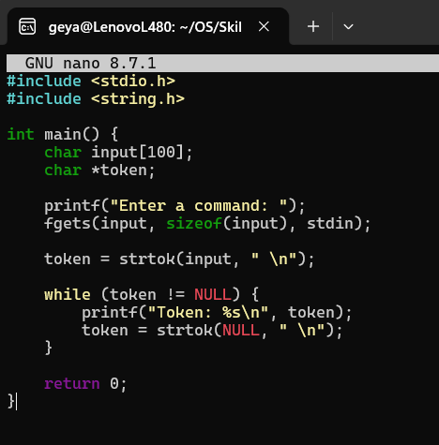

Output:

